**EMPLOYEE MANAGEMENT SYSTEM**

1. **CREATE DATABASE - MPHASIS**



1. **USE DATABASE NAME _ MPHASIS**



1. **CREATING TABLE**

**3.1 DEPARTMENTS TABLE**

**3.2** **EMPLOYEES TABLE**

**

**3.4** **LEAVEREQUESTS TABLE**

1. **INSERTING INTO TABLE**

**4.1.1 DEPARTMENTS TABLE INSERTION**

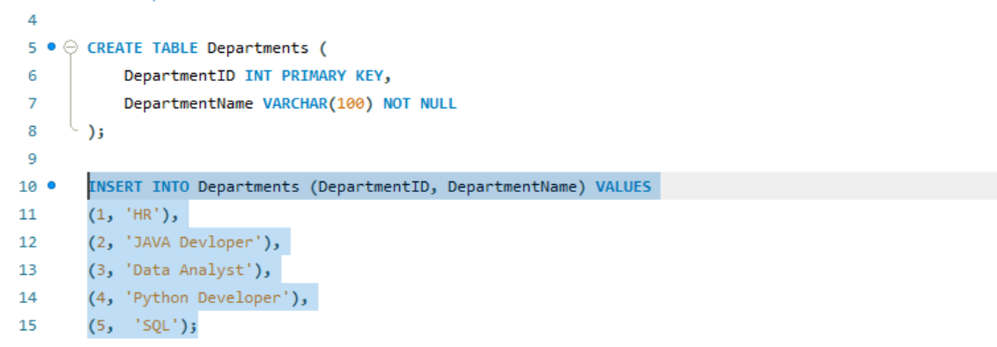

**4.1.2 SELECTION OF DEPARTMENTS**

* 1. **EMPLOYEES**

**4.2.1 INSERTING INTO EMPLOYEES**

* + 1. **SELCTION OF EMPLOYEES TABLE**

* 1. **ATTENDANCERECORDS**

**4.3.1 INSERTING INTO ATTENDANCERECORDS**

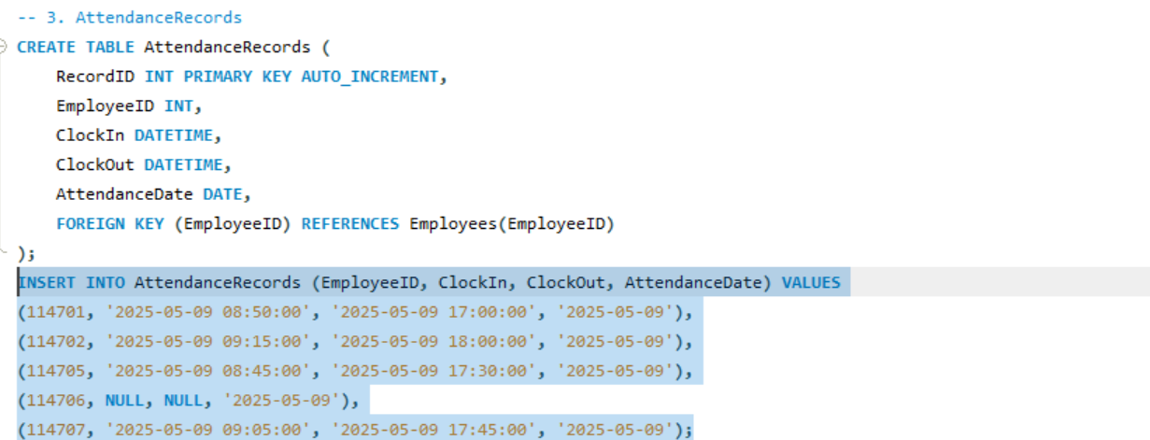

* + 1. **SELCTION OF ATTENDANCERECORDS**

* 1. **LEAVEREQUESTS**

**4.4.1 INSERTING INTO LEAVEREQUESTS**

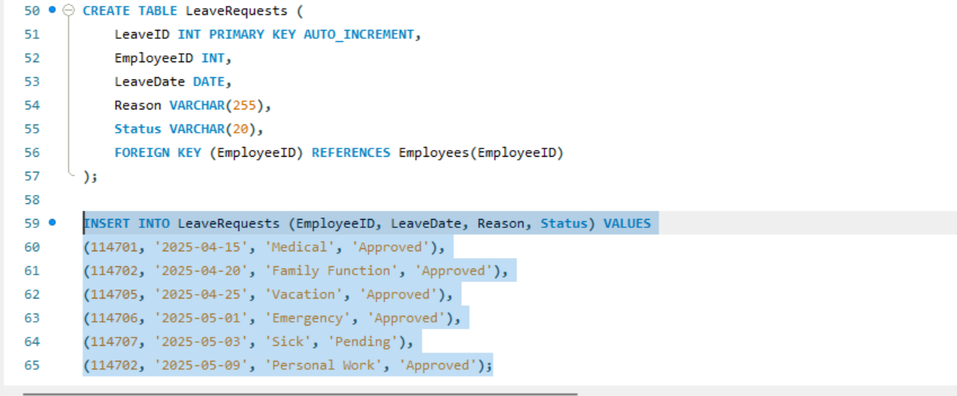

**4.4.2 SELECTION OF LEAVEREQUESTS TABLE**

1. **ALTERING COLUMN:**

**5.1.1 ALTERING TABLE EMPLOYEES FOR ADDING AGE AFTER NAME**

**5.1.2 UPDATING AGE COLUMN RECORDS**

1. **ALTERING CONSTRAINT:**

**6.1.1 ALTERING CONSTRAINTS FOR AGE CHECK**

**6.1.2 UPDATING THE TABLE TO VERIFY IF THE CONSTRAINTS ARE WORKING:**

1. **SHOW TABLES:**

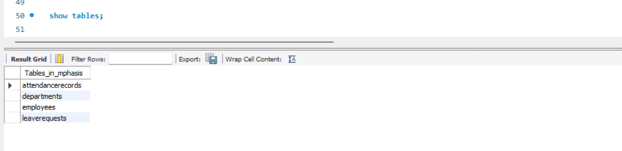

1. **DESC EMPLOYEES:**

1. **JOINS**

* **We are using the *Employees* and *Departments* tables to demonstrate different types of joins**
* **JOINS are classified into many types and I’m using 4 of them such are:**

1. **INNER JOIN**
2. **LEFT JOIN**
3. **RIGHT JOIN**
4. **CROSS JOIN**

* **EMPLOYEES TABLE**:

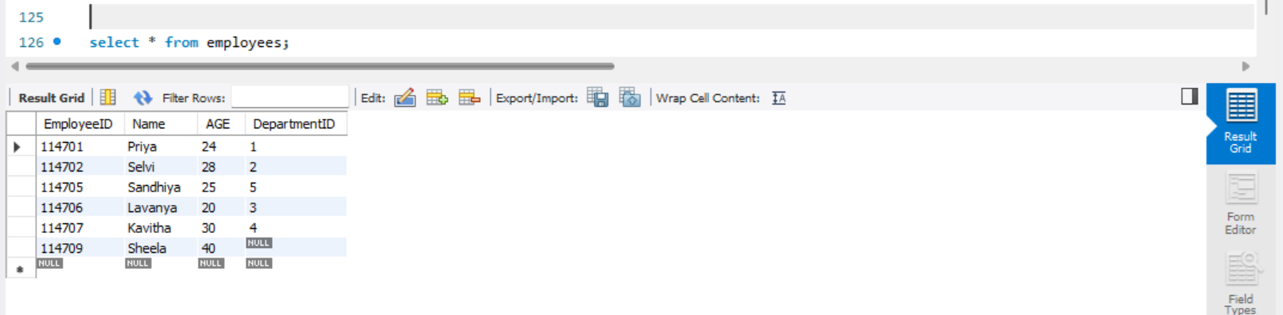

* **DEPARTMENTS TABLE**:

**9.1 INNER JOIN**:

**9.2 LEFT JOIN:**

**9.3 RIGHT JOIN**:

**9.4 CROSS JOIN:**

* + 1. **INNER JOIN EMPLOYEE&ATTENDANCE:**

**We are using Employees & Attendance table to demonstrate Inner Join**

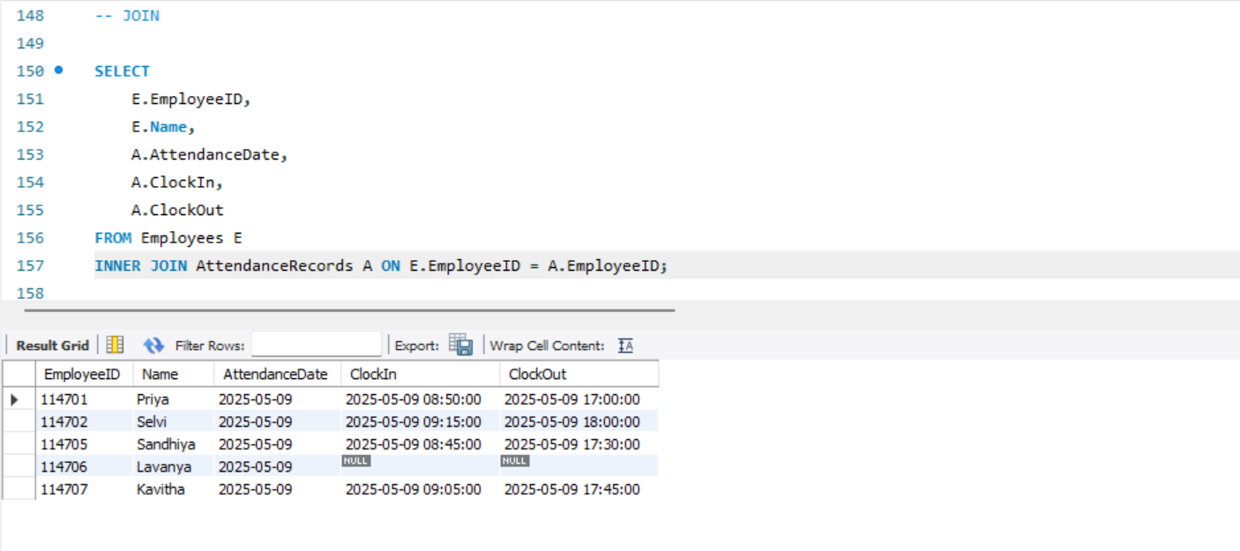

1. **VIEWS:**

We are using Employees&AttendanceRecords table to demonstate Views.

**10.1 SELECTING VIEW TABLE NAME**

1. **SUBQUERY**

**Here we are using Employees & Departments table to demonstrate Subquery**

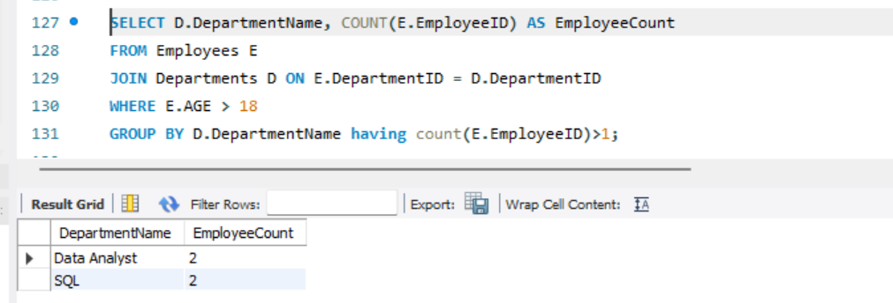

1. **PROCEDURES**

**12.1.1 CREATING PROCEDURE WITHOUT ARGUMENTS**

**12.1.2 CALLING PROCEDURES**

**12.2 CALLING PROCEDURES WITH ARGUMENTS:**



